4.Aim: a) Basic Spring Boot Application with Auto-Wiring.
Description:
This is a basic Spring Boot application that demonstrates Auto-Wiring and Bean Scopes.
- The Student class depends on the Marks class, and Spring automatically injects Marks into Student using @Autowired.
- @Component is used to register both classes (Student and Marks) as Spring Beans.
- In the main class “AutowiringApplication”, we retrieve the Student bean from the ApplicationContext and call its methods along with the Marks methods.

Folder Structure:
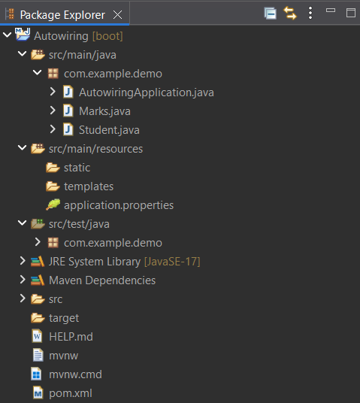

Program:

Marks.java
package com.example;

import org.springframework.stereotype.Component;

@Component
public class Marks {

public void display() {

System.out.println("marks class display method");
}
public void read() {

System.out.println("marks class read method");
}

}

Student.java
package com.example;

import org.springframework.beans.factory.annotation.Autowired;
import org.springframework.stereotype.Component;

@Component
public class Student {
@Autowired
public Marks m;

public void display() {

System.out.println("student class display method");
}

}

AutowiringApplication.java
package com.example;

import org.springframework.boot.SpringApplication;
import org.springframework.boot.autoconfigure.SpringBootApplication;
import org.springframework.context.ApplicationContext;

@SpringBootApplication
public class AutowiringApplication {

public static void main(String[] args) {
ApplicationContext
context=SpringApplication.run(AutowiringApplication.class, args);

Student s=context.getBean(Student.class);
s.display();
s.m.display();
s.m.read();

}

}

application.properties
spring.application.name=Autowiring
server.port=0000

pom.xml
<?xml version="1.0" encoding="UTF-8"?>
<project xmlns="http://maven.apache.org/POM/4.0.0" xmlns:xsi="http://www.w3.org/2001/XMLSchema-instance"
xsi:schemaLocation="http://maven.apache.org/POM/4.0.0 https://maven.apache.org/xsd/maven-4.0.0.xsd">
<modelVersion>4.0.0</modelVersion>
<parent>
<groupId>org.springframework.boot</groupId>
<artifactId>spring-boot-starter-parent</artifactId>
<version>3.5.5</version>
<relativePath/> <!-- lookup parent from repository -->
</parent>
<groupId>com.example</groupId>
<artifactId>AutowiringApplication</artifactId>
<version>0.0.1-SNAPSHOT</version>
<name>Autowiring</name>
<description>Demo project for Spring Boot</description>
<url/>
<licenses>
<license/>
</licenses>
<developers>
<developer/>
</developers>
<scm>
<connection/>
<developerConnection/>
<tag/>
<url/>
</scm>
<properties>
<java.version>17</java.version>
</properties>
<dependencies>
<dependency>
<groupId>org.springframework.boot</groupId>
<artifactId>spring-boot-starter-web</artifactId>
</dependency>

<dependency>
<groupId>org.springframework.boot</groupId>
<artifactId>spring-boot-starter-test</artifactId>
<scope>test</scope>
</dependency>
</dependencies>

<build>
<plugins>
<plugin>
<groupId>org.springframework.boot</groupId>
<artifactId>spring-boot-maven-plugin</artifactId>
</plugin>
</plugins>
</build>

</project>

Output:

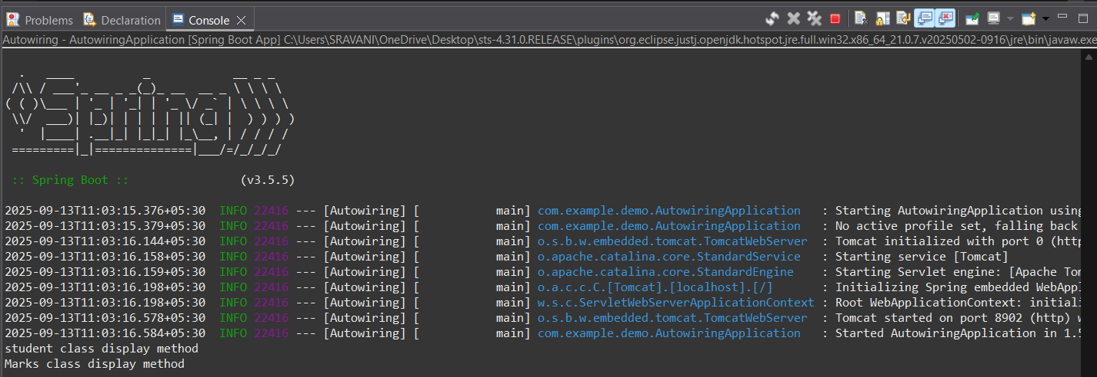

4.Aim: b) Basic Spring Boot Application with Bean Scopes.

Description:
This program explains the difference between Singleton and Prototype bean scopes in Spring Boot:
- Singleton Scope (@Scope("singleton")): Only one instance of the bean is created for the entire Spring container. Any request for that bean will return the same instance.
- Prototype Scope (@Scope("prototype")): A new instance of the bean is created every time it is requested from the container.
- SingletonBean is shared across requests. Changes in one reference affect the other. Where in PrototypeBean creates new objects each time, so changes in one object do not affect another.

Program:
ScopeDemoApplication.java

package com.example;
import org.springframework.boot.SpringApplication;
import org.springframework.boot.autoconfigure.SpringBootApplication;
import org.springframework.context.ConfigurableApplicationContext;
@SpringBootApplication
public class ScopeDemoApplication {
public static void main(String[] args) {
ConfigurableApplicationContext
context=SpringApplication.run(ScopeDemoApplication.class, args);
SingletonBean sb1=context.getBean(SingletonBean.class);
SingletonBean sb2=context.getBean(SingletonBean.class);
sb1.setCount(100);
sb2.setCount(200);
System.out.println(sb1.getCount());
System.out.println(sb2.getCount());
PrototypeBean pb1=context.getBean(PrototypeBean.class);
PrototypeBean pb2=context.getBean(PrototypeBean.class);
pb1.setCount(700);
pb2.setCount(800);
System.out.println(pb1.getCount());
System.out.println(pb2.getCount());
}
}
SingletonBean.java

package com.example;

import org.springframework.beans.factory.annotation.Value;
import org.springframework.context.annotation.Scope;
import org.springframework.stereotype.Component;

@Component
@Scope("singleton")
public class SingletonBean {

@Value("67")
public int count;
public int getCount() {
return count;
}
public void setCount(int count) {
this.count = count;
}
}

PrototypeBean.java

package com.example;

import org.springframework.beans.factory.annotation.Value;
import org.springframework.context.annotation.Scope;
import org.springframework.stereotype.Component;

@Component
@Scope("prototype")
public class PrototypeBean {

@Value("93")
public int count;
public int getCount() {
return count;
}
public void setCount(int count) {
this.count = count;
}
}
application.properties

spring.application.name=ScopeDemo
server.port=0000

pom.xml
<?xml version="1.0" encoding="UTF-8"?>
<project xmlns="http://maven.apache.org/POM/4.0.0" xmlns:xsi="http://www.w3.org/2001/XMLSchema-instance"
xsi:schemaLocation="http://maven.apache.org/POM/4.0.0 https://maven.apache.org/xsd/maven-4.0.0.xsd">
<modelVersion>4.0.0</modelVersion>
<parent>
<groupId>org.springframework.boot</groupId>
<artifactId>spring-boot-starter-parent</artifactId>
<version>3.5.5</version>
<relativePath/> <!-- lookup parent from repository -->
</parent>
<groupId>com.example</groupId>
<artifactId>ScopeDemoApplication</artifactId>
<version>0.0.1-SNAPSHOT</version>
<name>ScopeDemo</name>
<description>Demo project for Spring Boot</description>
<url/>
<licenses>
<license/>
</licenses>
<developers>
<developer/>
</developers>
<scm>
<connection/>
<developerConnection/>
<tag/>
<url/>
</scm>
<properties>
<java.version>17</java.version>
</properties>
<dependencies>
<dependency>
<groupId>org.springframework.boot</groupId>
<artifactId>spring-boot-starter-web</artifactId>
</dependency>

<dependency>
<groupId>org.springframework.boot</groupId>
<artifactId>spring-boot-starter-test</artifactId>
<scope>test</scope>
</dependency>
</dependencies>

<build>
<plugins>
<plugin>
<groupId>org.springframework.boot</groupId>
<artifactId>spring-boot-maven-plugin</artifactId>
</plugin>
</plugins>
</build>

</project>

Output:

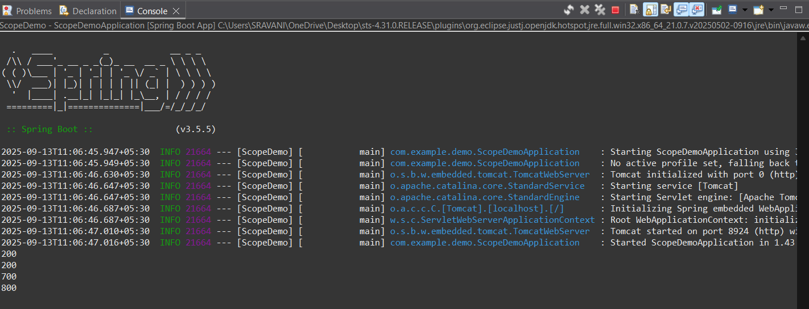

5.Aim: Basic Spring Boot Application with Bean Scopes.
Description:
This program demonstrates how to implement logging in a Spring Boot application using SLF4J (Simple Logging Facade for Java) and LoggerFactory.
- We created a LogController that logs messages at different log levels: TRACE, DEBUG, INFO, WARN & ERROR.
- The logging behavior is configured in application.properties.
- Another controller MyController is added to test a simple message response.

Program:

LogController.java
package com.example;

import org.slf4j.Logger;
import org.slf4j.LoggerFactory;
import org.springframework.web.bind.annotation.RequestMapping;
import org.springframework.web.bind.annotation.RestController;

@RestController
public class LogController {
Logger logger= LoggerFactory.getLogger(LogController.class);

@RequestMapping("/log")
public String logger()
{
logger.trace("Log level: TRACE");
logger.info("Log level: INFO");
logger.debug("Log level: DEBUG");
logger.error("Log level: ERROR");
logger.warn("Log level: WARN");
return "Hey! You can check the output in the logs";
}

}

MyController.java
package com.example;

import org.springframework.web.bind.annotation.GetMapping;
import org.springframework.web.bind.annotation.RestController;

@RestController
public class MyController {

@GetMapping("/msg")
public String msg()
{
return("Spring Boot application successfully executed");
}

}

LoggingApplication.java
package com.example;

import org.springframework.boot.SpringApplication;
import org.springframework.boot.autoconfigure.SpringBootApplication;

@SpringBootApplication
public class LoggerApplication {

public static void main(String[] args) {
SpringApplication.run(LoggerApplication.class, args);
}

}

application.properties
spring.application.name=Logger
logging.level.root=INFO
logging.level.com.example=DEBUG
server.port=0000

pom.xml
<?xml version="1.0" encoding="UTF-8"?>
<project xmlns="http://maven.apache.org/POM/4.0.0" xmlns:xsi="http://www.w3.org/2001/XMLSchema-instance"
xsi:schemaLocation="http://maven.apache.org/POM/4.0.0 https://maven.apache.org/xsd/maven-4.0.0.xsd">
<modelVersion>4.0.0</modelVersion>
<parent>
<groupId>org.springframework.boot</groupId>
<artifactId>spring-boot-starter-parent</artifactId>
<version>3.5.5</version>
<relativePath/> <!-- lookup parent from repository -->
</parent>
<groupId>com.example</groupId>
<artifactId>LoggingApplication</artifactId>
<version>0.0.1-SNAPSHOT</version>
<name>Logging</name>
<description>Demo project for Spring Boot</description>
<url/>
<licenses>
<license/>
</licenses>
<developers>
<developer/>
</developers>
<scm>
<connection/>
<developerConnection/>
<tag/>
<url/>
</scm>
<properties>
<java.version>17</java.version>
</properties>
<dependencies>
<dependency>
<groupId>org.springframework.boot</groupId>
<artifactId>spring-boot-starter-web</artifactId>
</dependency>

<dependency>
<groupId>org.springframework.boot</groupId>
<artifactId>spring-boot-starter-test</artifactId>
<scope>test</scope>
</dependency>
</dependencies>

<build>
<plugins>
<plugin>
<groupId>org.springframework.boot</groupId>
<artifactId>spring-boot-maven-plugin</artifactId>
</plugin>
</plugins>
</build>

</project>

Output:

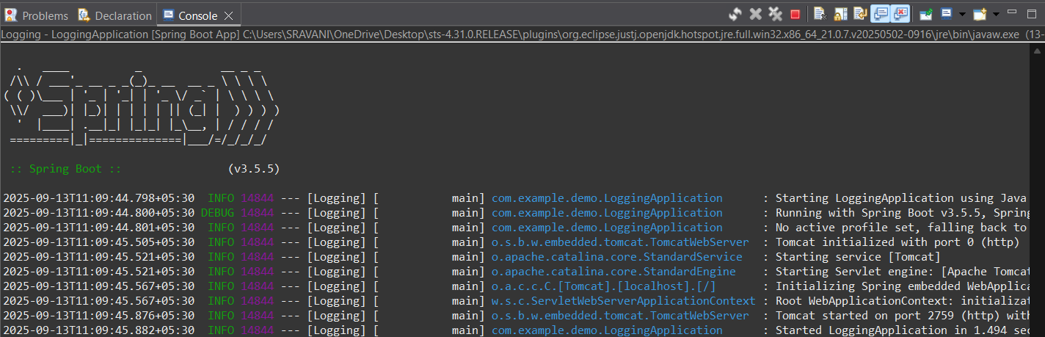

6.Aim: Implementing and Using AOP in Spring Boot
Description:
Aspect-Oriented Programming (AOP) in Spring Boot is used to separate cross-cutting concerns (like logging, transactions, security) from the main business logic.
In this example:

- We create a Service (MyService) that prints a message.
- We define an Aspect (MyAspect) with @Before and @After advice that runs before and after the sayHello() method.
- The Main Application (TodayApplication) runs the service using CommandLineRunner.
- Dependencies in pom.xml include “spring-boot-starter-aop” to enable AOP support.

Program:
MyAspect.java
package com.example;

import org.aspectj.lang.annotation.After;
import org.aspectj.lang.annotation.Aspect;
import org.aspectj.lang.annotation.Before;
import org.springframework.stereotype.Component;

@Aspect
@Component
public class MyAspect {

@Before("execution(* com.example.MyService.sayHello(..))")
public void beforeMethod() {
System.out.println("Before: Method is about to run");
}
@After("execution(* com.example.MyService.sayHello(..))")
public void afterMethod() {
System.out.println("After: Method has run");
}
}
MyService.java
package com.example;
import org.springframework.stereotype.Service;
@Service
public class MyService {
public void sayHello() {
System.out.println("welcome to aop programming");
}
}

ThirdApplication.java
package com.example;
import org.springframework.boot.CommandLineRunner;
import org.springframework.boot.SpringApplication;
import org.springframework.boot.autoconfigure.SpringBootApplication;

@SpringBootApplication
public class ThirdApplication implements CommandLineRunner{

public MyService myservice;

public ThirdApplication(MyService myservice) {
super();
this.myservice = myservice;
}

public static void main(String[] args) {
SpringApplication.run(ThirdApplication.class, args);
}

@Override
public void run(String... args) {
myservice.sayHello();

}
}

application.properties
spring.application.name=Today
server.port=0000
pom.xml

<project xmlns="http://maven.apache.org/POM/4.0.0" xmlns:xsi="http://www.w3.org/2001/XMLSchema-instance" xsi:schemaLocation="http://maven.apache.org/POM/4.0.0 https://maven.apache.org/xsd/maven-4.0.0.xsd">
<modelVersion>4.0.0</modelVersion>
<groupId>abc</groupId>
<artifactId>ThirdLabExp</artifactId>
<version>0.0.1-SNAPSHOT</version>
<dependencies>
<!-- https://mvnrepository.com/artifact/org.springframework/spring-core -->
<dependency>
<groupId>org.springframework</groupId>
<artifactId>spring-core</artifactId>
<version>5.3.34</version>
</dependency>
<!-- https://mvnrepository.com/artifact/org.springframework/spring-context -->
<dependency>
<groupId>org.springframework</groupId>
<artifactId>spring-context</artifactId>
<version>5.3.34</version>
</dependency>

</dependencies>
</project>

Output:

